ADMINISTRATION Training for Administrators -KAC Documentation under review
VOLUNTEERS settings:
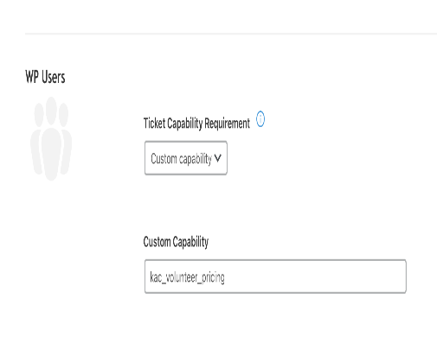

MEMBERS settings:
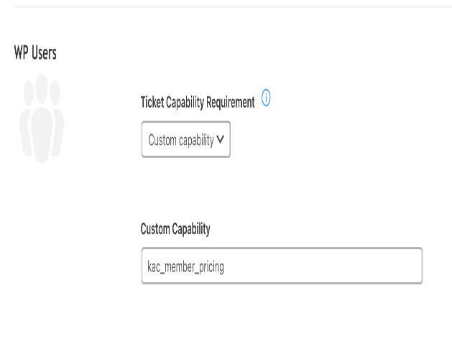

This setting “Ticket Capability Requirement” can be left at NONE for tickets that are available to the general public.

Other Notes: Another few updates:

Wait List defaults for events! New events should show the waitlist settings as “100” spots and Auto Promote set to “YES”.

Finally, I the other day I was checking a few things and noticed that there were some settings not set on tickets, just wanted to clarify these items, since you didn’t have any documentation to know to set it up this way.

Please ensure your ticket type permissions are set properly so they appear correctly to the right membership.

To properly restrict a ticket for volunteers or members, you need to set the following custom capability to the ticket when creating it.

